‘Move’ task Name: Advisory:
due in week 4 HASS lessons
PART 1:
Throughout human history people have moved about, sometimes seasonally, sometimes permanently. Sometimes whole communities, sometimes families, sometimes individuals. Why does this happen?

People who study this aspect of Geography say that there are two main reasons for movement of populations: ‘Push’ factors and ‘Pull’ factors. Push factors occur within countries that people are leaving, while pull factors exist within countries that receive immigrants.

Push factors: Factors that drive people to leave home. Push factors come in many forms. Sometimes these factors leave people with no choice but to leave their country of origin. Below are three examples of push factors that drive people to emigrate from their home countries. Naturally there are others.
- Lack of Jobs/Poverty
- Civil Strife/War/Political and Religious Persecution
- Environmental Problems

Pull factors: Factors that attract migrants to a new location. Pull factors are responsible for dictating where these travelers end up. The positive aspects of some countries serve to attract more immigrants than others. Below are three examples of pull factors that draw migrants to receiving countries. There are others, of course.
- Higher standards of living/Higher wages
- Labor Demand
- Political and Religious Freedom

When considering Hamid from Afghanistan in the ‘Go Back to Where You Came From’ series, explain what Push factors might have influenced him to leave Afghanistan?

…………………………………………………………………………………………………………………………………………………………………………………………………………………………………………………………………………………………………………………………
……………………………………………………………………………………………………………………………………………………………
…………………………………………………………………………………………………………………………………………………………………………………………………………………………………………………………………………………………………………………………

Explain what Pull factors might promote Australia as a preferred destination?

……………………………………………………………………………………………………………………………………………………………
……………………………………………………………………………………………………………………………………………………………………………………………………………………………………………………………………………………………………………………………………………………………………………………………………………………………………………………………………………………………………………………………………………………………………………………………………………………………………………………

Do some research if necessary and determine the main differences between an asylum seeker, a refugee and a migrant:

………………………………………………………………………………………………………………………………………………………………………………………………………………………………………………………………………………………………………………………………………………………………………………………………………………………………………………………………………………………
What were the top 3 countries for accepting refugees (as of mid-2015)? (You will need to use http://www.worldatlas.com/articles/countries-hosting-the-largest-number-of-refugees-in-the-world.html)

- ……………………………………….

- ……………………………………….

- ……………………………………….

What do these countries have in common? Why have these particular countries hosted so many refugees in recent times? (You may find the website above useful when answering this question)
……………………………………………………………………………………………………………………………………………………………
………………………………………………………………………………………………………………………………………………………………………………………………………………………………………………………………………………………………………………………………………………………………………………………………………………………………………………………………………………………

In response to a rising number of boat arrivals in 2001, the Howard Government introduced what came to be known as the ‘Pacific Solution’ whereby asylum seekers on board unauthorised—or irregular maritime arrival (IMA)—vessels were intercepted (usually by the Australian navy) and transferred to offshore processing centres on Nauru and Manus Island in Papua New Guinea. Read the following excerpt from the Australian Parliament on the Pacific Solution and answer the questions that follow:
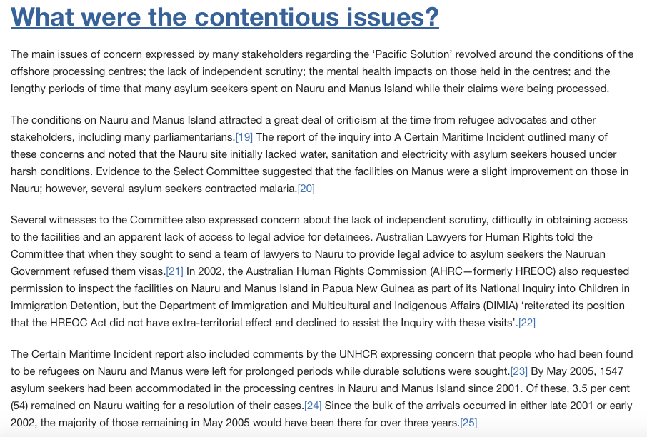
(Figure 1: Excerpt from the Pacific Solution revisited)

What were the main issues with the Pacific solution as stated in paragraph 1 of the article?

……………………………………………………………………………………………………………………………………………………………
………………………………………………………………………………………………………………………………………………………………………………………………………………………………………………………………………………………………………………………………………………………………………………………………………………………………………………………………………………………

In paragraph 3, why would the Department of Immigration and Multicultural and Indigenous Affairs (DIMIA) decline to assist the Australian Human Rights Commission (AHRC) with their inquiry into the facilities on Nauru and Manus Island?

……………………………………………………………………………………………………………………………………………………………
…………………………………………………………………………………………………………………………………………………………………………………………………………………………………………………………………………………………………………………………………………………………………………………………………………………………………………………………………………………………………………………………………………………………………………………………………………………………………………………………………………………………………………………………………………………………………………………………………………………

Use the graph below to answer the questions that follow:
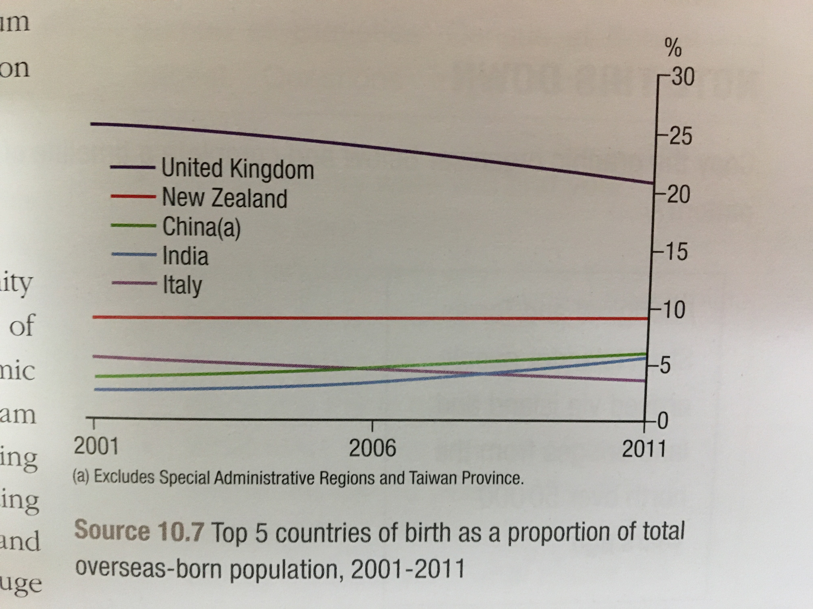
(Figure 2: Top 5 countries of birth as a proportion of total overseas-born population, 2001-2011)

Identify the number 1 country of birth of overseas-born Australians in 2011 …………………………………………

Discuss the changing trends in the countries of birth of overseas-born Australians between 2001-2011.
……………………………………………………………………………………………………………………………………………………………
…………………………………………………………………………………………………………………………………………………………………………………………………………………………………………………………………………………………………………………………
PART 2:
View the table below and answer the questions that follow:
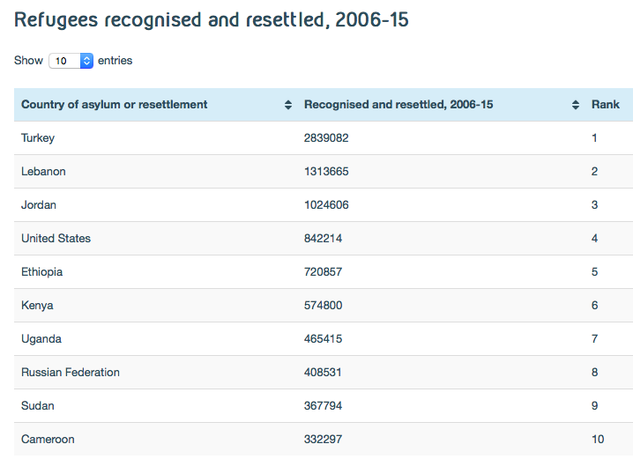
(Figure 3: The number of refugees recognized and resettled between 2006-15 in each of the top 10 receiving countries)

Australia recognized and resettled 139,398 refugees in the same time.
Use Excel or another similar program to create an appropriate graph that shows the top 10 host countries’ intakes as compared with Australia’s. Label and attach the graph to this sheet.

What does your graph highlight?
……………………………………………………………………………………………………………………………………………………………
…………………………………………………………………………………………………………………………………………………………………………………………………………………………………………………………………………………………………………………………

Go to The Refugee Project’s website at www.therefugeeproject.org and navigate the timeline to 2015. Use the map to discover how many refugees fled Burundi in 2015: ……………………….

Use the information on the site to explain the main reason such a high number of people fled Burundi:
……………………………………………………………………………………………………………………………………………………………
…………………………………………………………………………………………………………………………………………………………………………………………………………………………………………………………………………………………………………………………
……………………………………………………………………………………………………………………………………………………………

EXTENSION:
Propose an alternative to the Australian Government using off-shore detention centres such as Nauru and Manus Island, taking account of environmental, economic and social factors, and predict the outcomes and consequences of their proposal.

Proposal
Factors
Environmental | Economic | Social
Predict the outcomes and consequences

AUSTRALIAN CURRICULUM CONTENT DESCRIPTORS
Geography
Apply geographical concepts to synthesise information from various sources and draw conclusions based
on the analysis of data and information, taking into account alternative points of view (ACHGS068) & (ACHGS077)
AUSTRALIAN CURRICULUM CAPABILITIES
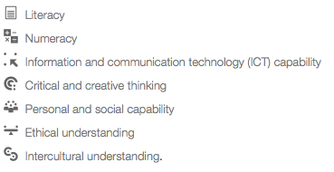 | ✔
 | ✔
 | ✔
 | ✔
 | ✔
 |      ✔

Achievement Standards Rubric
 | A | B | C | D | E
Data analysis  (Part 1) | Students synthesis data and information to draw highly insightful conclusions. | Students synthesise data and information to draw detailed, reasoned conclusions. | Students synthesise data and information to draw reasoned conclusions. | Students draw few reasoned conclusions | Students draw no reasoned conclusions
Graph and explanation  (Part 2) | Students present insightful findings, arguments and explanations using relevant geographical terminology and digital representations in a range of appropriate communication forms. | Students present appropriate findings, arguments and explanations using relevant geographical terminology and digital representations in a range of appropriate communication forms. | Students present findings, arguments and explanations using relevant geographical terminology and digital representations in a range of appropriate communication forms. | Students present some findings, arguments and explanations. | Students present no findings, arguments and explanations.
Action Proposed  (Extension) | Students propose detailed and thoughtful action, taking account of environmental, economic and social factors, and predict the outcomes and consequences of their proposal. | Students propose appropriate action, taking account of environmental, economic and social factors, and predict the outcomes and consequences of their proposal. | Students propose action, taking account of environmental, economic and social factors, and predict the outcomes and consequences of their proposal.

