‘Mapped’ task Name: Advisory:
due in week 5 HASS lessons
AUSTRALIAN CURRICULUM CONTENT DESCRIPTORS
Geography
Represent spatial distribution of geographical phenomena by constructing special purpose maps that conform to cartographic conventions, using spatial technologies as appropriate (ACHGS066) & (ACHGS075).

PART 1: Where is this happening?

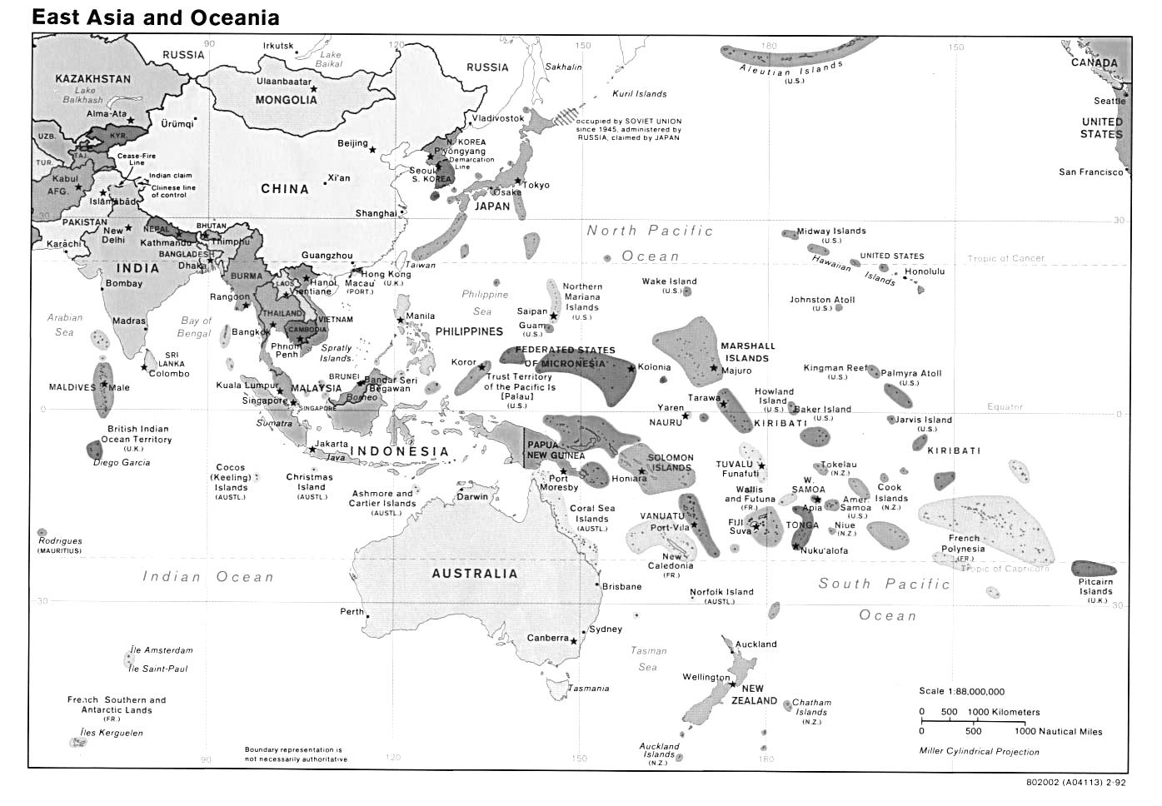
- Label the following on the map:
  - Nauru with a red ‘DC’ (detention centre)
  - Manus Island with a red ‘DC’
  - Christmas Island with a red ‘DC’
  - Adelaide with a red ‘A’
  - Kabul, Afghanistan with a red ‘K’

- Using the scale of the map use a ruler to work out the ‘straight line’ distance (in kilometers) from Adelaide to the following:
  - Nauru = ______________________ kms
  - Manus Island = ______________________ kms
  - Christmas Island = ______________________ kms
  - Kabul = ______________________ kms

- Now work out the distance of the following to the closest point of the Australian mainland:
  - Nauru = ______________________ kms
  - Manus Island = ______________________ kms
  - Christmas Island = ______________________ kms
  - Kabul = ______________________ kms

- What direction are the following (eg. North, south-east):
  - Adelaide from Kabul = _______________________________
  - Christmas Island from Perth = _______________________________
  - Christmas Island from Darwin = _______________________________
  - Nauru from Darwin = _______________________________

- Using a protractor, geoliner or other, work out the bearing (in degrees) of:
  - Darwin from Hanoi = _______________________________
  - Hanoi from Perth = _______________________________
  - Manus Island from Adelaide = _______________________________

PART 2: Representing data on maps.

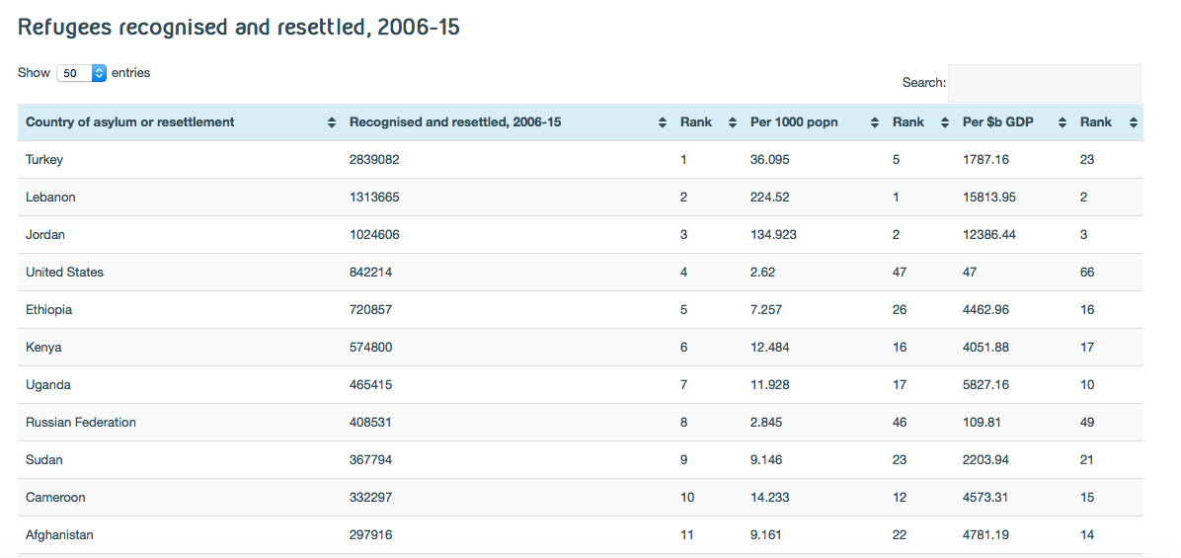
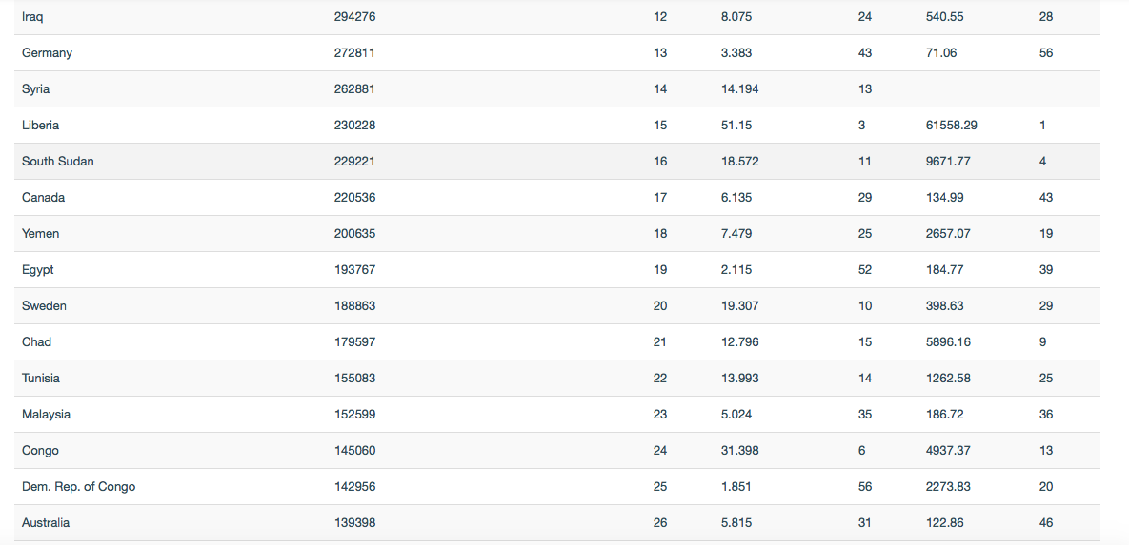
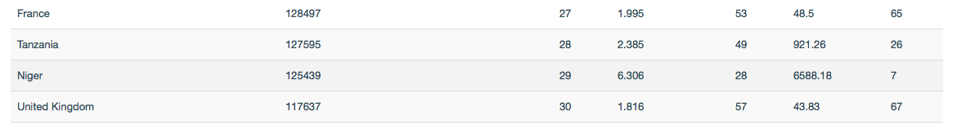(Source: the Refugee Council.org)

Use the table above, which list the number of refugees recognised and resettled for the top 30 host countries in the world, to create a visual representation of the countries that host the most refugees. On the map below design a way to visually show the number of refugees recognised and settled by the top 30 countries without writing the exact numbers hosted. You may wish to use symbols, colours or another form of representation but you will need to include a key/legend to explain. If you would prefer, you may create this on computer and staple to this sheet.

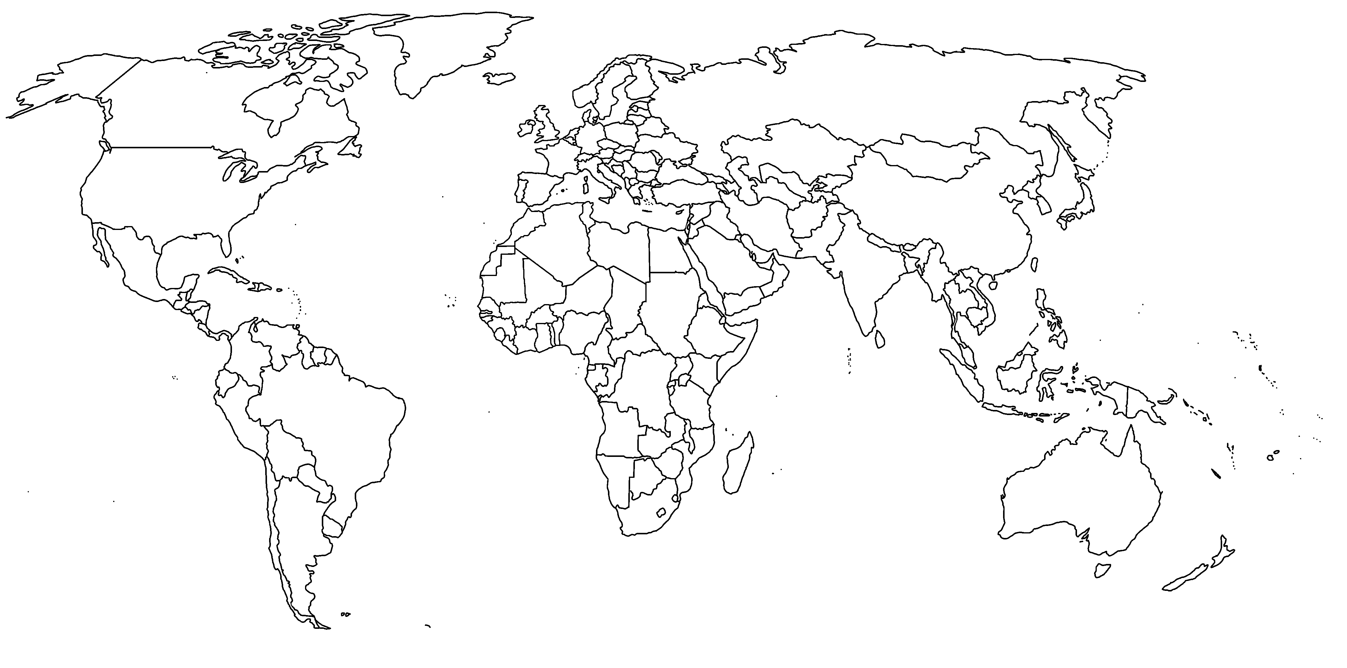
Top 30 countries for refugee recognition and resettlement 2006-2015
Legend:

Extension:
Find your own data (raw data or graph) from a reliable source that suggests Australia IS ‘pulling its weight’ when it comes to receiving refugees. When found attach it, and an explanation to this sheet.

Achievement Standards Rubric
 | A | B | C | D | E
Using a map  (Part 1) | Student uses a range of methods and digital technologies to interpret and analyse maps highly effectively | Student uses a range of methods and digital technologies to interpret and analyse maps effectively. | Student uses a range of methods and digital technologies to interpret and analyse maps. | Student attempts to interpret and analyse maps. | Student makes no attempt to interpret and analyse maps.
Representing data on a map  (Part 2) | Student develops a highly effective method to represent data on a map. | Student represents data on a map effectively. | Student represents data on a map. | Student attempts to represent data on a map. | Student makes no attempt to represent data on a map.
(Extension) | Student sources and explains detailed and reliable data that suggests Australia is ‘pulling its weight’ in terms of receiving refugees. | Student sources and explains reliable data that suggests Australia is ‘pulling its weight’ in terms of receiving refugees. | Student sources data that suggests Australia is ‘pulling its weight’ in terms of receiving refugees.

