Ballads as Literature and History
Creating a Ballad inspired by art and quotation.
Due Date: Name: Advisory:
Australian Curriculum

Year 9 Content Descriptions

Language
Text structure and organisation: Understand that authors innovate with text structures and language for specific purposes and effects (ACELA1553)

Literature
-Literature and context: Interpret and compare how representations of people and culture in literary texts are drawn from different historical, social and cultural contexts (ACELT1633)
-Creating literature: Create literary texts, including hybrid texts, that innovate on aspects of other texts, for example by using parody, allusion and appropriation (ACELT1773)

Literacy
Creating texts: Create imaginative, informative and persuasive texts that present a point of view and advance or illustrate arguments, including texts that integrate visual, print and/or audio features (ACELY1746)
Use a range of software, including word processing programs, flexibly and imaginatively to publish texts (ACELY1748)

Year 9 Achievement Standard
Students:
- analyse the ways that text structures can be manipulated for effect. They analyse and explain how images, vocabulary choices and language features distinguish the work of individual authors.
- select evidence from texts to analyse and explain how language choices and conventions are used to influence an audience. They listen for ways texts position an audience.
-understand how to use a variety of language features to create different levels of meaning. They understand how interpretations can vary by comparing their responses to texts to the responses of others. In creating texts,
- demonstrate how manipulating language features and images can create innovative texts.
- create texts that respond to issues, interpreting and integrating ideas from other texts. They make presentations and contribute actively to class and group discussions, comparing and evaluating responses to ideas and issues.
- edit for effect, selecting vocabulary and grammar that contribute to the precision and persuasiveness of texts and using accurate spelling and punctuation.

Task
Historians often use works of art as primary sources to understand the past. They look at the artwork very carefully searching for clues about life at the time and place they were created. Art includes paintings, text and songs. Each of these presents a unique way of analysing the past.
Synthesis is the ability to take information from sources and transfer it to another.

In this task you will examine paintings from the 19th century, as well as some written quotes from that era. You will copy and paste your chosen art piece as well as a chosen quote on to the centre of a blank page, then analyse the important meanings you get from each. You will then apply your knowledge of poetry [see HOW TO COMPOSE A BALLAD] to compose your own bush-ballad that suits the era we are studying and describes life conditions at that time.

You may use ANY picture and quote from 19th century Australia, although you are welcome to use the ones on this sheet.

You may present your ballad as a poem, without tune, or set your ballad to any tune, old or new, or [for the brave] you might compose your own tune. Present your ballad in text form and if you do compose a tune add a recording of the song being sung [get some friends or talented students to help] or even arrange for a live performance.
Hints for Analysing Artwork
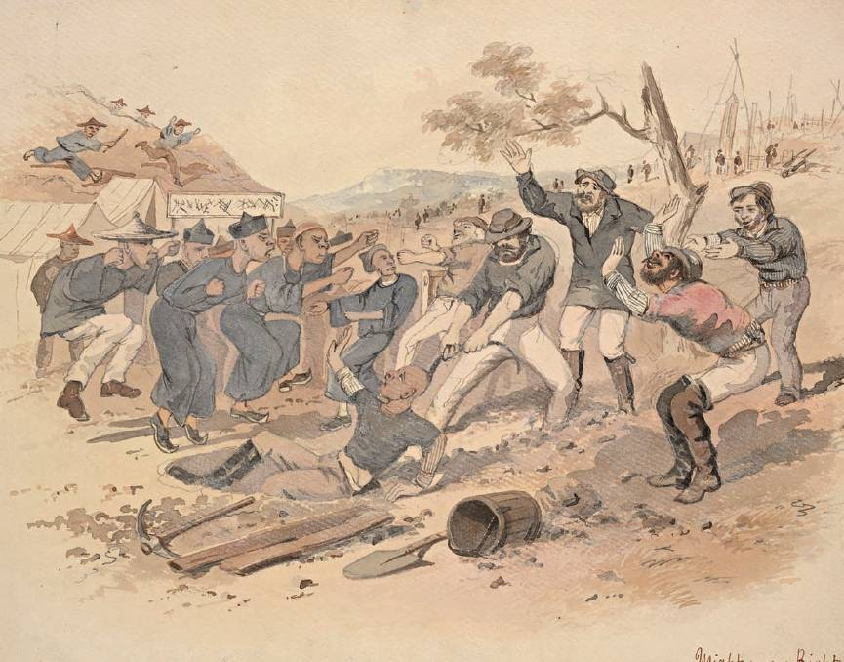
Look closely at every aspect of the artwork, asking yourself: - “What is going on here and how do I know?” Consider what is the main message, theme or idea you get from this picture? What does this tell us something about clothing, mining, living conditions, women, health or something else? For example, the picture opposite shows mistreatment of a Chinese miner [notice his tools]. You can tell then attitude of the other Chinese people as well as the white onlookers by their facial expressions and body language. Notice also what is going on in the background, armed Chinese are coming to help. Does this tell us that the Chinese were completely helpless victims?

Examples of Artwork
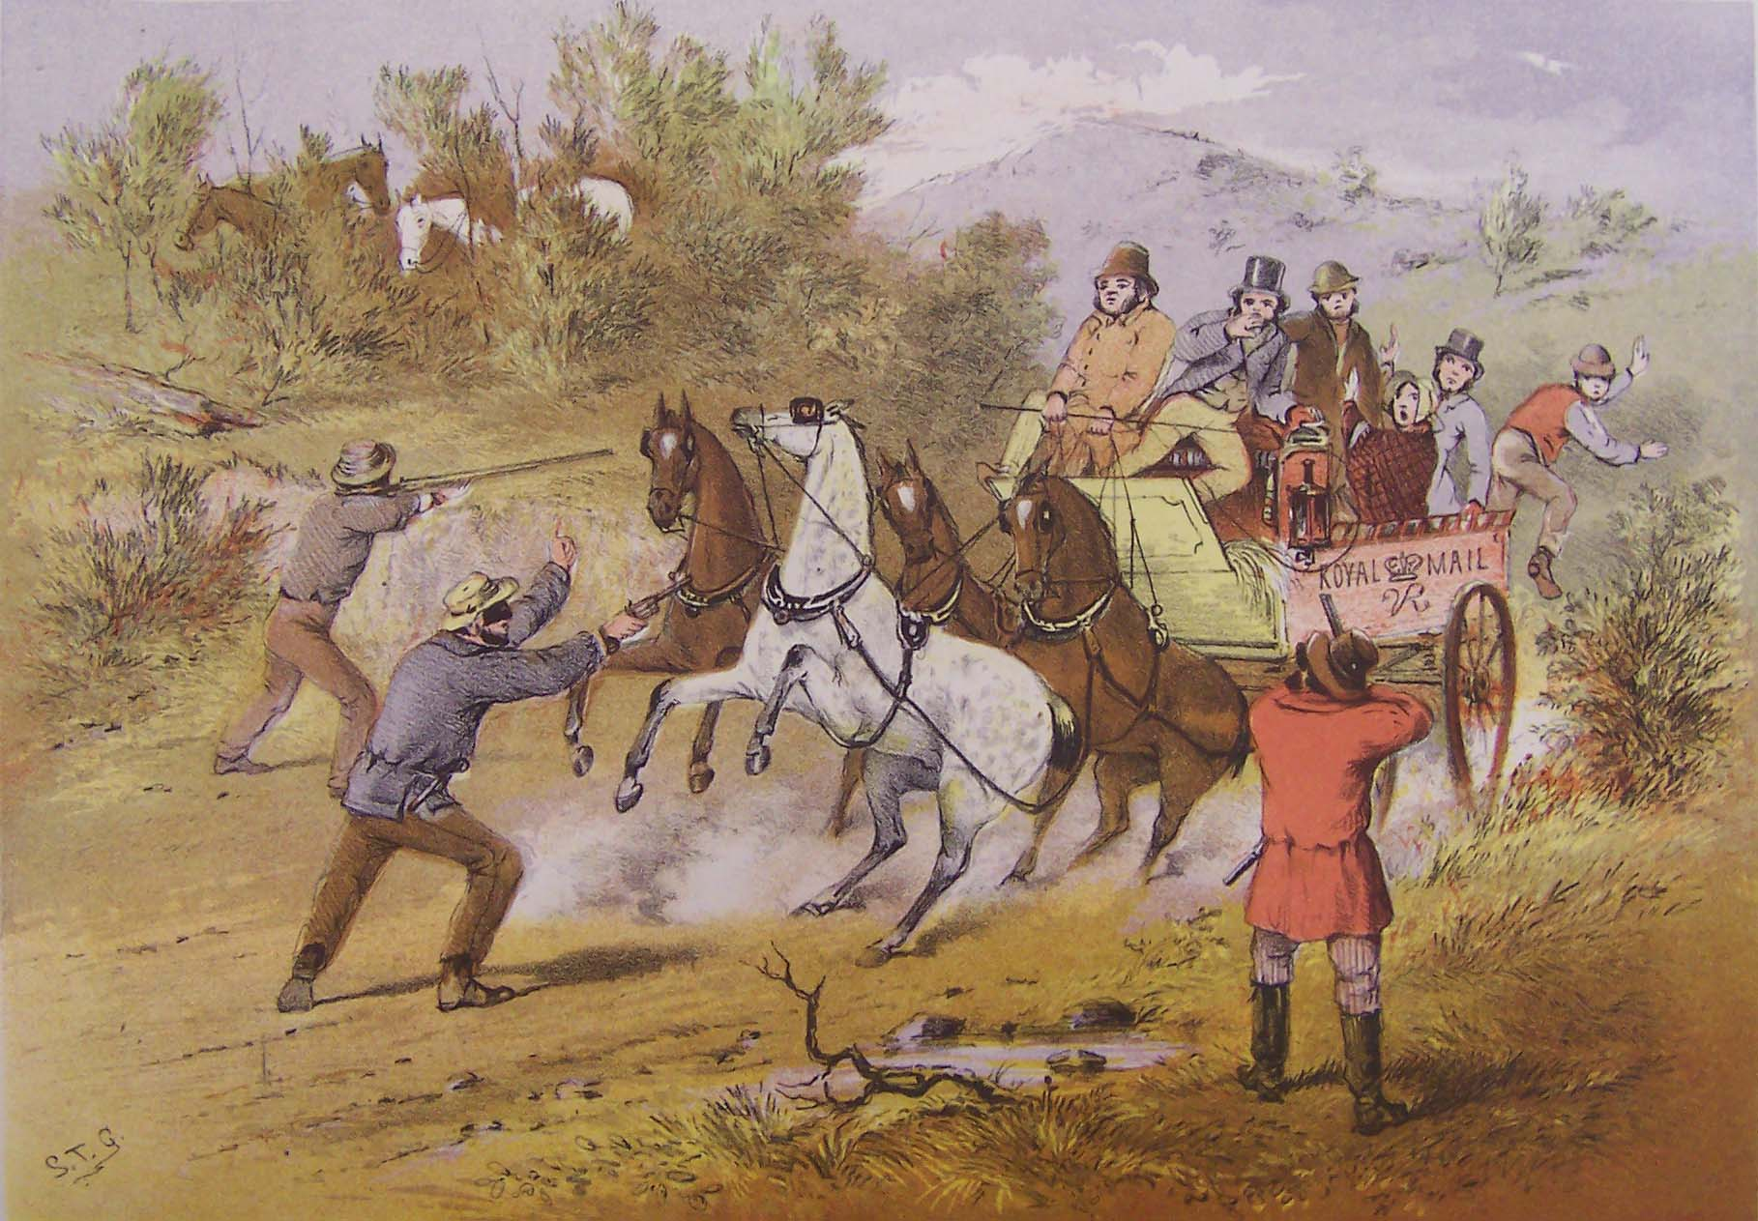

“Really, one can form no idea at home, even in the 'School for Scandal' of a small country town, of the bickerings, jealousies etc. of the people in 'this fair country'.” - Visiting observer S.H. Clutterbuck's diary, Melbourne, 17 September, 1850.

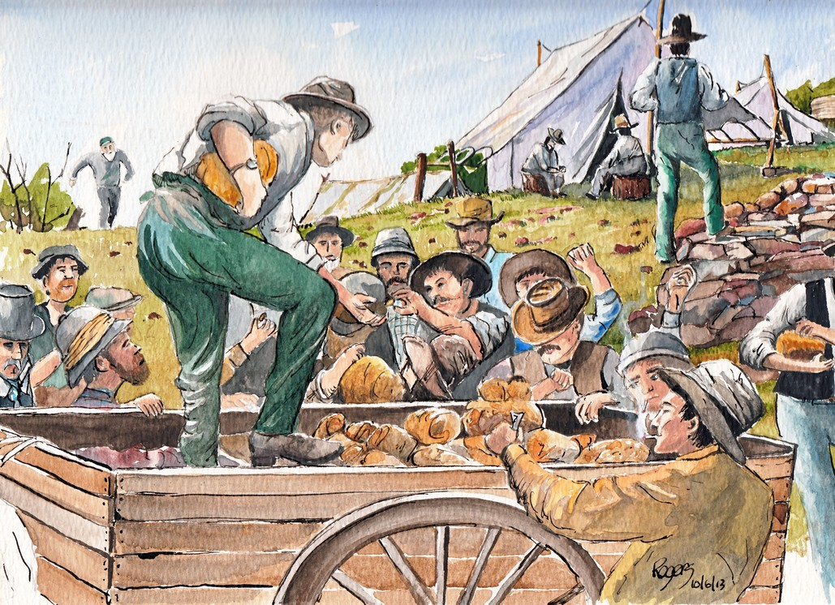

With bread at almost a shilling a loaf, often stale from being transported from Melbourne by slow cart, most of us bought rough flour, often picking out the weevils, and with a bit of dripping, salt and some scraped off yeast mold, we made our own and called is ‘damper’.
It was rough stuff, baked in a campfire. We dipped a chunk into a mugful of tea and supped it down. Revolting, but it filled the belly, and what more can you ask for a penny?
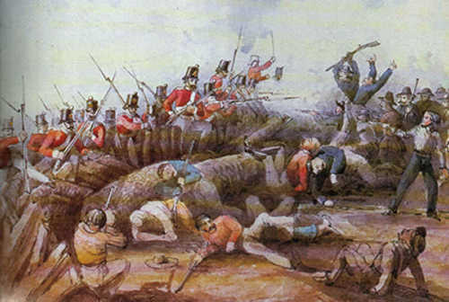
'Her Majesty's forces were this morning fired upon by a large body of evilly-disposed persons' (Government Notice, Ballarat, 3 December, 1854)
QUEEN Victoria ruled the world and there was no brighter jewel in her crown than the new colony named in her honour. No sooner had Victoria been separated from NSW in 1850, it seemed, than it unveiled some of the richest goldfields on earth.

NEW YEARS DAY!!! OLD WHITE HART INN, GREAT BOURKE STREET. The lovers of the good old English merriment are invited to witness the different sports opposite the above Inn on TUESDAY NEXT consisting of GOAT RACING - PRIZE, A SUIT OF CLOTHES, CLIMBING THE GREASY POLE - PRIZE, HAT AND GUN, A PIG RACE WITH GREASY TAILS. QUOITING AND SKITTLES. The whole to conclude with a GRAND MATCH at the old English game of FOOTBALL. Luncheon will be provided. - Advertisement for New Year's Day amusement, Melbourne, 1850.

You may use ANY picture and quote from 19th century Australia, although you are welcome to use one on this sheet.

Assessment Rubric

Criteria | 4 | 3 | 2 | 1 | 0
Evaluation and Integration | Ideas integrated and evaluated in a detailed and sophisticated, detailed manner to form new texts of high quality, clearly demonstrating interpretations | Ideas clearly integrated and evaluated in detail to form new texts to demonstrate interpretations | Ideas integrated and evaluated to form new texts to demonstrate own interpretations. | Ballad only relates to texts in a shallow or vague way. Little evaluation of text connections | Ballad does not relate to other texts
Language features creating levels of meaning | New text demonstrates sophisticated understanding of how to use a wide variety of language features to create many different levels of meaning. | New text demonstrates mature understanding of how to use a wide variety of language features to create different levels of meaning. | New text demonstrates understanding of how to use a variety of language features to create different levels of meaning. | Few language features are used, and these only vaguely create meaning. | Language features are not used appropriately to enhance the sense of meaning
Creating Innovative texts | Language features are manipulated with skill and precision, using strong, evocative imagery to create an innovative text using  an appropriate  Poetic form, complete with more than four stanzas with four or more lines each and  figurative language  to reinforce the theme | Language features are manipulated with skill, using strong imagery to create an innovative text, effectively using  an appropriate  Poetic form, complete with four stanzas of four lines each and figurative language to reinforce the  theme. | Demonstrates how manipulating language features and images can create innovative texts using an  appropriate poetic  form.  Fewer than four stanzas of four lines each with figurative language to  reinforce the  theme. | Little use of language features to create an  innovative text Uses an  Inappropriate  Poetic form.  Too few stanzas or stanza length is incorrect. Little figurative language used. | Text is basic and non- No poem completed or presented. No figurative or descriptive language used.
Responding to  Issues | Text responds  to issues explicitly; extending the interpretation and integrating of ideas from other texts in detail. | Text responds  to issues explicitly; interpreting and integrating ideas from other texts in detail. | Text responds  to issues, interpreting and integrating ideas from other texts. | Text only responds to issues indirectly, only vaguely interpreting and integrating ideas from other texts. | Text does not engage with other material.

/16

How to Write a Ballad

- Understand what a ballad is. A ballad is a poem or song that focuses on a specific story. Often, ballads are about love--either lost or found-- or about an event or interaction that says something about the human condition. They are thought of as romantic and are often tragic. Reading ballads by other writers can be very helpful when you are trying to come up with your own ballad. Traditional British ballads can be funny, tragic, or even satirical, often tackling themes like
love, work, and death.

- Pick a theme for your ballad. Ballads tell stories that often tackle themes like scandal, love, death, disaster, or even current events. They usually follow a clear, linear storyline, relying on plotted action (an unsettled situation, a climax, and a resolution) to build suspense. Since many tell (or retell) traditional stories that have been circulating for generations, you can also adapt a well-known tale to ballad form if you don’t wish to write one from complete scratch.

Often, the theme of the ballad will make us feel a certain way about our own lives. Tragic ballads
that focus on lost love are meant to remind us to be grateful of the lives we lead and the love we
experience.

- Pick an event or tale to describe in your ballad. The topic can range from a significant historical event that affected thousands, to a small, personal moment you had in your own life. Once you have chosen a particular event or person(s) to focus on, do a bit of research so that you can pick which parts of the story you want to tell, and which are unnecessary for the advancement of the narrative and theme.

- Single out the most important elements of the plot. Ballads use a narrative style known as “leaping and lingering” – that is, skipping over non-essential plot points so that more time can be spent on the interesting moments. To mimic this style, cut any unnecessary backstory, plot connections, or secondary details that distract from the plot of the story you've chosen.

Stagger Lee, the example ballad for this article, is a classic American blues ballad about the murder
Of Billy Lions at the hand of Stagger Lee, who overreacted when Billy knocked the hat from his
head. Salacious stories like this usually make for very popular ballads.

- Find a starter phrase. The opening line of a ballad is often the hardest to write, but it is also the most important, because it is what draws the reader or listener in and makes him or her feel like he/she a part of the story. Ballads often open with stock phrases such as the come-ye-all salutation. (Ex. “Come all ye maidens,” “Come all ye comrades,” etc.) Feel free to borrow this phrase to get your story going (and make your ballad more authentic to boot). If you don’t want to use a starter phrase, focus on introducing the reader to the story.

Mississippi John Hurt’s version of Stagger Lee jumps right into the action by opening with, Police
officer, how can it be?

- Use plenty of descriptive language, using adjectives describe sights, sounds, tastes, smells and touch. Make your ballad ‘alive’ for your audience so that they are involved with your story, so they can relate closely to what you are saying.

- Also include figurative language, like metaphors, similes, hyperbole, to extend your meaning beyond the obvious. Examples of poetic figurative language might include: All right, the sky misses the sun at night; The poorest man is the richest, and the rich are poor; Out of reach, I pull out with a screech; I move fast like a cheetah on the Serengeti. Her head was spinning from all the new information; The toast jumped out of the toaster; The Sea lashed out in anger at the ships, unwilling to tolerate another battle; I’ve told you a million times to clean your room
- Establish a rhythm and rhyme scheme. Ballads typically have four-line verses, of which two or more rhyme. The easiest way to get started with the rhythm and rhyme is to complete the first verse however you like it, then use it as the basis for the rest of the lines in the verse (eg. keeping the length, rhythm, and end rhyme of each line more or less consistent).

An AA rhyme is when the first and second line rhyme.
AABB: The first two lines are a rhyming pair and the second two lines are a new rhyming pair.
ABAB: The first and third line rhyme and the second and fourth line rhyme.
ABCB: Only the second and fourth lines rhyme.
Example from Stagger Lee (first three lines are AAB, which is a traditional ballad rhyme scheme.):
Police officer, how can it be?
You can 'rest everybody but cruel Stagger Lee
That bad man, cruel Stagger Lee.

- Write the chorus. Once again, the chorus is very flexible in ballad form. It can be one line that is repeated in every verse, two lines that are repeated every few verses, an entire verse, or even two verses back-to-back. Additionally, you can repeat the chorus verbatim or change it slightly each time for dramatic effect.

This version of Stagger Lee includes the chorus at the end of every verse (The chorus is That bad man, oh cruel Stagger Lee):
Police officer, how can it be?
You can 'rest everybody but cruel Stagger Lee
That bad man, oh, cruel Stagger Lee

- Write a second verse in the same style as the first. Use a consistent meter (i.e. try to keep the same lyrical rhythm as you did in the first verse). The meter is basically the pattern of syllables in a song or poem. Most ballads use the same meter throughout the song, or the meter for the chorus may differ from that of the verses. This is what dictates the rhythm. This following Poem has 3 lines, other than typical 4-lined ballads. By extending the sentences to other lines, you will be able to see it morph into a poem looking ballad.

Billy de Lyon told Stagger Lee, "Please don't take my life,
I got two little babies, and a darlin' lovin' wife."
That bad man, oh, cruel Stagger Lee

- Complete the ballad using your structural template. Once you have the verse style down, you just need to complete your story following the same structural guidelines you. Don't be a slave to that structure, though. If you need to vary the length of a line or even of a verse here and there, go ahead and do it, and if you want to deviate from your rhyme pattern feel free to do so if it will make your ballad better.

- Keep in mind that some ballads, like Stagger Lee, can have the chorus built into each verse. In these cases, the rhyme scheme is often AAB (see above) or ABAC (where the two-line chorus occupies the second and fourth lines, B and C, of each verse).

Lines that "go together" should have roughly the same number of syllables and accented
syllables.

Here is the competed Ballad Stagger Lee:

Police officer, how can it be?
You can 'rest everybody but cruel Stagger Lee
That bad man, oh, cruel Stagger Lee

Billy de Lyon told Stagger Lee, "Please don't take my life,
I got two little babies, and a darlin' lovin' wife."
That bad man, oh, cruel Stagger Lee

"What I care about you little babies, your darlin' lovin' wife?
You done stole my Stetson hat, I'm bound to take your life."
That bad man, cruel Stagger Lee
“Boom-boom, boom-boom,” went the forty-four
When I spied Billy de Lyon, he was layin' down on the floor
That bad man, oh cruel Stagger Lee
"Gentlemen of the jury, what do you think of that?
Stagger Lee killed Billy de Lyon about a five-dollar Stetson hat."
That bad man, oh, cruel Stagger Lee.
And all they gathered, hands way up high,
At twelve o'clock they killed him, they're all glad to see him die
That bad man, oh, cruel Stagger Lee

