9 AIL Targeted Teaching Mathematics – Takeaway
Scatterplots
Name _________________________________ Advisory ______________ T² Teacher ___________________
T² Teaching Focus
Real life is messy, so it is expected that measurements taken from real life will be messy as well. When you graph measurements of real life, it is expected that the dots won't line up exactly in a nice neat line, but will instead form a scattering of dots. Sometimes these dots might suggest a nice neat line, sometimes they roughly look like a line and other times the dots are all over the place. These dots are called a scatterplot. We use scatterplots to determine whether there is a relationship or correlation between two variables. In a statistics experiment, the dependent variable is the event studied and expected to change whenever the independent variable is altered. In scatterplots the independent variable is plotted on the x axis and the dependent variable on the y axis.
A scatterplot like this has a perfect positive correlation. 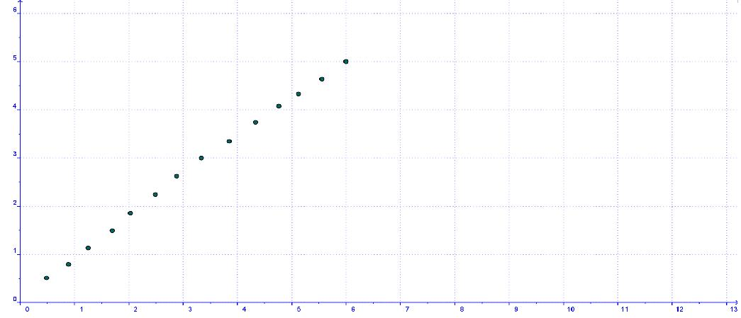
One like this has a strong positive correlation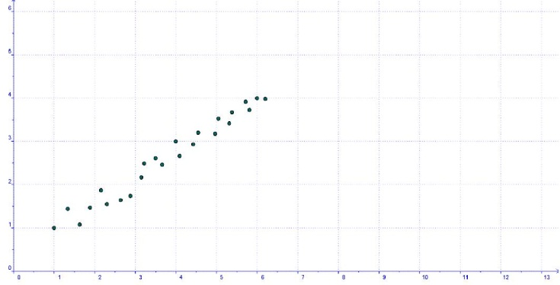
This one has a low negative correlation 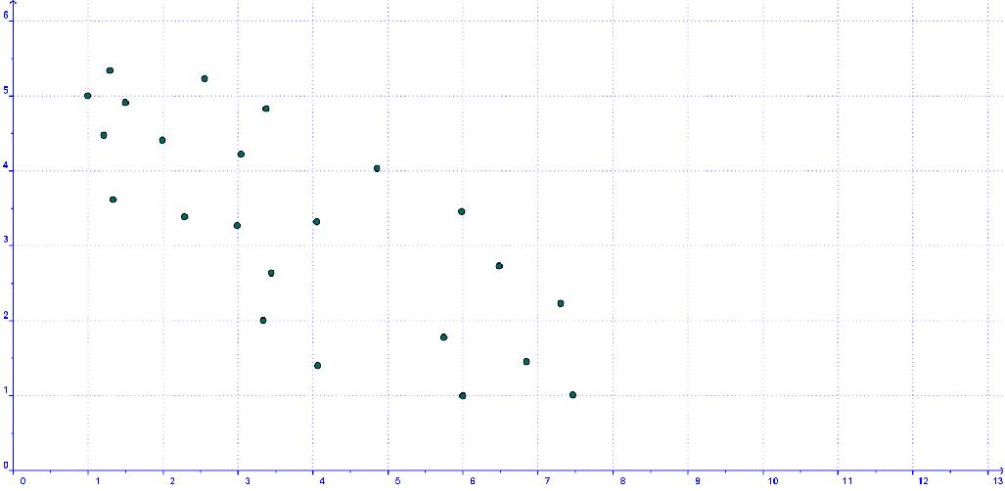
And this one has no correlation 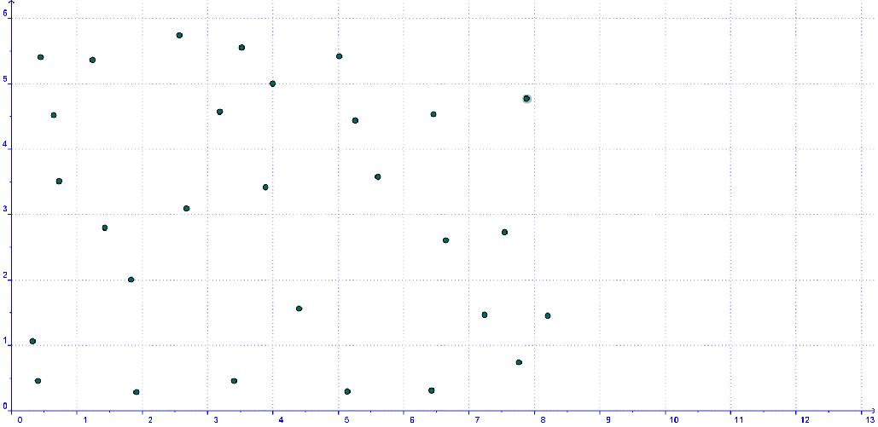

T2 Teaching example
Do you think that if you spend longer studying for a test you will get a higher mark?
Time spent studying in hours | Test score  If you think yes, then you think there is a relationship or correlation between these two variables. ie one of these has an effect on the other. Intuitively you would expect that the longer you spend studying, the higher the test score. ie as one goes up so does the other, so you expect this to be a positive correlation.
4 | 19
8 | 35
1 | 10
9 | 41  In the table to the left we see how many hours 9 different students studied for a test and what score they got in that test. These are plotted below.
12 | 53
2 | 12
7 | 32  The dependent variable (Test score ) is the Y axis and the independent variable (Hours spent studying is the x axis)
5 | 29
11 | 47

The dots in the scatterplot above are pretty close to being in a straight line. So we would call this a strong correlation. The graph is going ‘up’ so it is a strong positive correlation. Hence this shows that how long you study does effect your score in the test and the higher the number of hours spent the higher the test score.

Touch Base Tasks:
For the three examples below,
- State whether the data is Primary or Secondary data.
- Identify the independent and dependent variable/
- Draw a scatterplot for each.
- Determine the nature of the correlation ie whether it is positive, negative or no correlation and whether it is perfect, strong, low or none.
- Write a brief explanation of what information you can therefore determine from these scatterplots.
Example 1) 30 champion basket-ballers took one shot each from 1 metre, 2 metres, 3 metres, 4 metres, 5 metres and 10 metres from the basket. How many of them scored a basket at each of the distances is shown in the table below. Is there a correlation between these two variables?
Distance from the basket | Number who scored
1 | 29
2 | 27
3 | 26
4 | 22
5 | 16
10 | 3

Example 2) Measure the height (without shoes) and the arm length of 10 of your friends to see if there is a correlation between the two.
Example 3) Below is how much the full forwards were paid in 10 different football teams, and how many goals they scored in a season. Is there a correlation between the two?

Paid per match | Goals scored in the season
$100 | 34
$50 | 65
$200 | 50
$40 | 120
$65 | 98
$250 | 112
$175 | 24
$10 | 46
$0 | 87
$300 | 15

These tasks will be reviewed in the Tutorial Session in the next Maths Targeted Teaching Time.

