9 – AIL - MATHS INVESTIGATION DUE: WEEK - 5
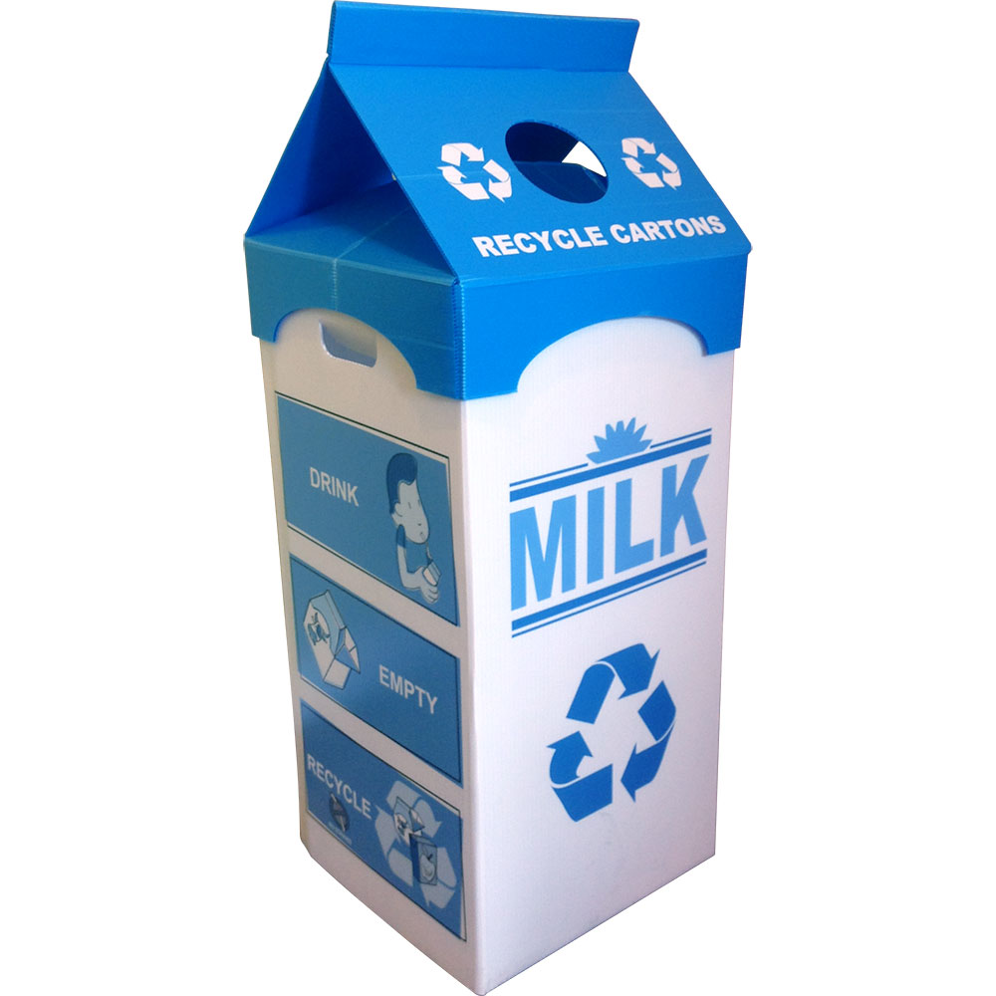

The humble milk carton

In this environmentally conscious age, manufacturers are always looking for the most efficient and economical ways of packaging food and drink.

Investigation Question:

Does it take more cardboard to make two separate 1-L milk cartons or one 2-L carton?

ENGAGE:

- Make a 3-D pencil diagram of your milk carton.
- Find the dimensions (length, width and height) of the part of the milk carton that holds the milk (you may need to make some assumptions). Do these dimensions give a volume of 1L? Label them on the diagram and calculate to show how these dimensions give a volume of 1-L.

EXPLORE:

- Carefully open out the carton along its seams and make a scale drawing of
the net of the carton.
- Find the area of the cardboard required to make the carton.
- Find the minimum area of cardboard required to make a 2-L carton. Show your calculations.

EXPLAIN:

- Make a scale drawing of the net of your 2-L carton. Calculate and show
how its dimensions give a volume of 2-L.

ELABORATE:

- (a) Use your answers to Question 4&5 to answer the Investigation ques.
(b) Does it take twice as much cardboard to make a carton with twice the volume?
(c) Which carton is more efficient form of packaging?

EVALUATE:

- Explain any assumptions you have made in your calculations of area
and volume for both the 1-L and 2-L cartons.
- List the advantages and disadvantages of selling milk in 2-L instead of
1-L cartons.

