Name and Advisory: ___________________________
Controlling the Body
Nervous System/Endocrine System
The HNS (Human Nervous system), the communication system that controls all parts of your body using electrical signals consists of the:
- Central Nervous System CNS: brain and spinal cord
- Peripheral Nervous System PNS: Nerves that carry messages to the other parts of your body.
Answer all questions in sentences!

Station 1
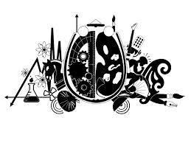
Brain Test
Are you left or right brained?
The brain consists of 2 main halves, known as the cerebrum. Each half is called the right or left cerebral hemisphere. The right hemisphere controls the left side of your body and the left controls your right.

Take the following test to determine whether you are left or right brained.
http://en.sommer-sommer.com
Put your results in the following space
.……………………………………………………………………………………….....................................
1 mark
From the website answer these questions.
- What are the characteristics of the left-brain?
………………………………………………………………………………………......................................
………………………………………………………………………………………......................................
2 marks
- What are the characteristics of the right-brain?
………………………………………………………………………………………......................................
………………………………………………………………………………………......................................
2 marks
- Do you agree with the test? Explain why or why not.
………………………………………………………………………………………......................................
………………………………………………………………………………………......................................
2 marks
- What is the CNS and the PNS?
………………………………………………………………………………………......................................
………………………………………………………………………………………......................................
2 marks

Station 2
Blood pressure and heart rate
Measure your blood pressure with the Sphygmomanometer
Is your blood pressure and heart rate connected?
- Sit quietly for 2 minutes. Do Not Talk!
- Now take your resting blood pressure using the sphygmomanometer
Resting Blood Pressure ……………………………..
- Now exercise for 2 minutes by stepping up and down on a step. (use the steps outside)
- Now take you blood pressure using the same method.
Exercising blood pressure ………………………………….
Did your blood pressure change? Explain why or why not.
………………………………………………………………………………………......................................
………………………………………………………………………………………......................................
2 marks

Station 3
Heart Rate
- Sit quietly for 2 minutes. Do Not Talk!
- Now take your resting heart rate and count the beats for 15secs
- Multiply by 4 and record.
Resting Heart Rate ……………………………..
- Now exercise for 2 minutes by stepping up and down on a step. (use the steps outside)
- Now take you heart rate using the same method.
Exercising Heart Rate ………………………………….
- What should your maximal heart rate be using the formula below?
………………………………………………………………………………………......................................
Maximal Heart Rate 220 beats/min − age in years
3 marks

Station 4
How do your eyes detect colour and motion?
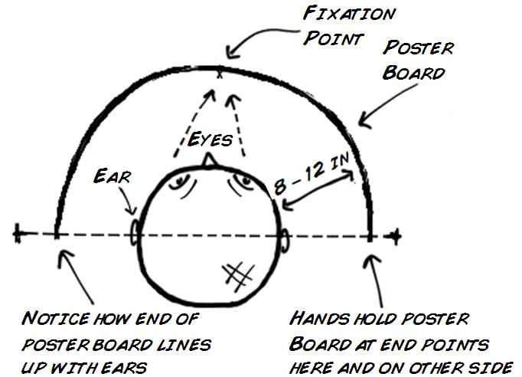
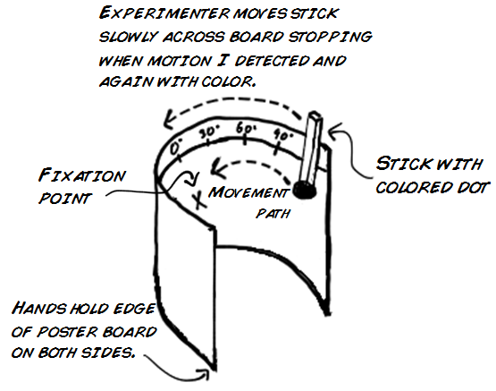

Try the experiment and complete the table below.
Name | Degree colour was detected | Degree movement was detected
3 marks
- Which was detected 1st, colour or movement?
………………………………………………………………………………………......................................
- What organ has control over your eye?
………………………………………………………………………………………......................................
- Where do you actually see images that the eye detects?
………………………………………………………………………………………......................................
3 marks

Station 5
Light in your eyes.
- Look at your friend’s pupils.
- Now shine a torchlight into one of your friends eyes.
- Explain what has happened to your pupil and why your body responds in this way.
………………………………………………………………………………………......................................
………………………………………………………………………………………......................................
2 marks
- What controls the action of the pupil? Explain where the message travels to activate the movement of the pupil.
………………………………………………………………………………………......................................
………………………………………………………………………………………......................................
2 marks

Station 6
Nerves
- Look at the slide of the nerve cell (neuron) and a muscle cell
- In the space provided draw the structure of one cell using a pencil.

4 marks

- Now have a go at making your own slide using the ‘blended brain’. Draw a diagram of what you see.

Brain Cell
Research and then answer these questions:
- What is the purpose of a sensory neuron?

………………………………………………………………………………………......................................
………………………………………………………………………………………......................................
2 marks
- What is the purpose of the motor neuron?

………………………………………………………………………………………......................................
………………………………………………………………………………………......................................
2 marks

Station 7
Common:9ailstudentaccess2015:Endocrine System
Work your way through the program and answer these questions.
The Endocrine System
Explain in detail what the endocrine system does.
………………………………………………………………………………………......................................
………………………………………………………………………………………......................................
………………………………………………………………………………………......................................
………………………………………………………………………………………......................................
………………………………………………………………………………………......................................
2 marks
Give an example of the endocrine system in action. Use 1 gland as an example.
………………………………………………………………………………………......................................
………………………………………………………………………………………......................................
………………………………………………………………………………………......................................
………………………………………………………………………………………......................................
………………………………………………………………………………………......................................
2 marks
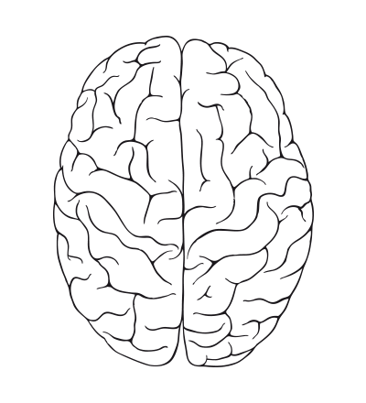
Total 36

