**Title of your historical event**

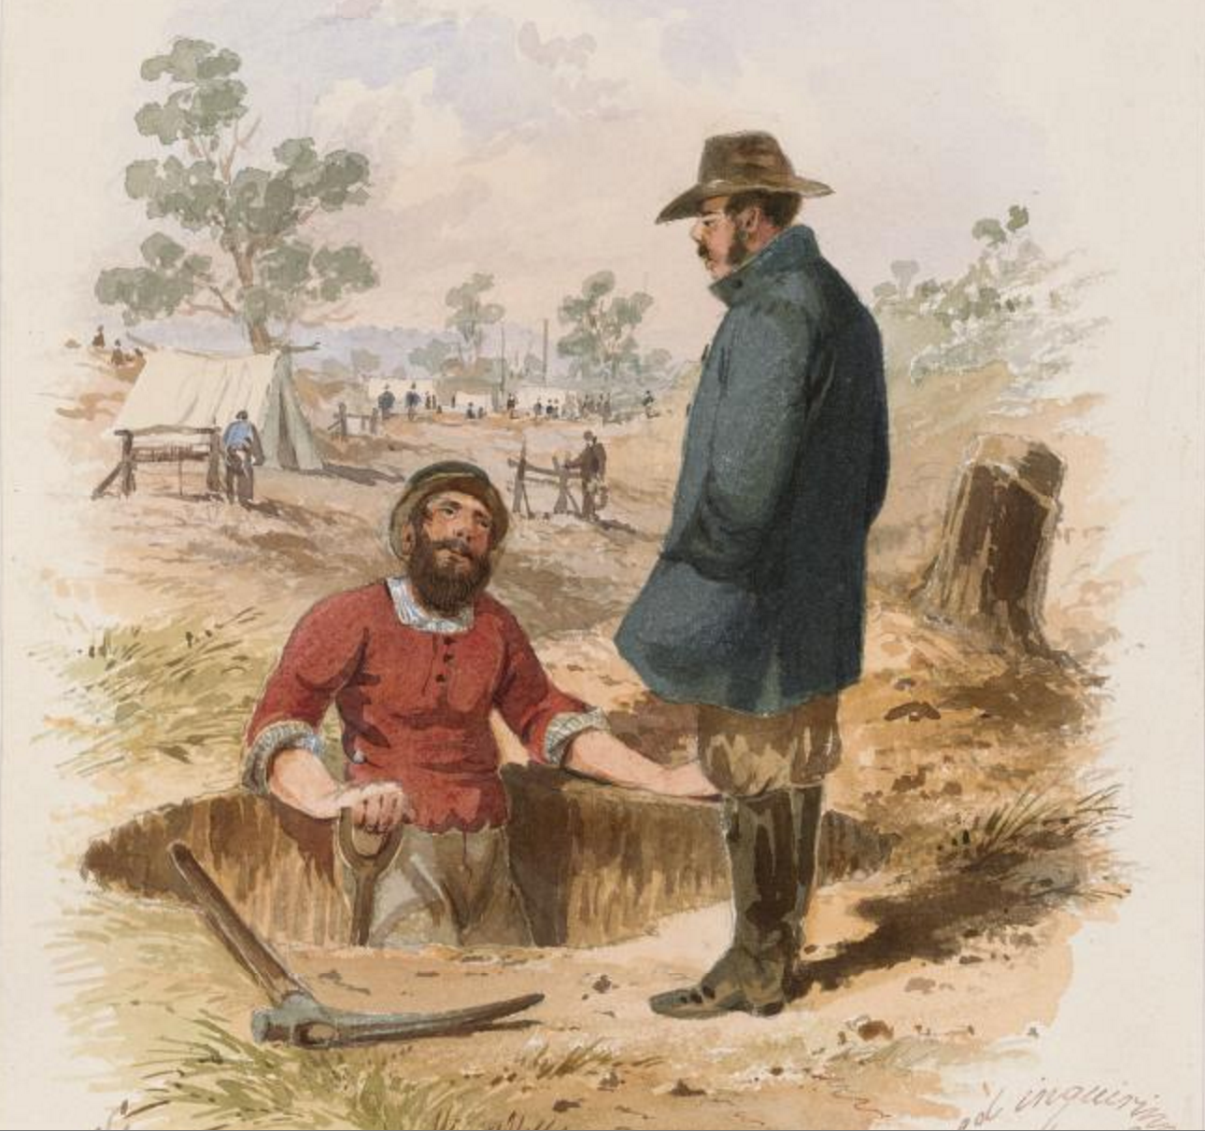

**Where did it occur?**

yvtdvdy buyfty buyftf gytdtrd buyftf gytdtrd utfrdyt tdtrfuy tdrtdfyu rdytfu tftyuy tfuy itfi u ifdwartt iifytf t.

**Who was involved?**

yvtdvdy buyfty buyftf gytdtrd buyftf gytdtrd utfrdyt tdtrfuy tdrtdfyu rdytfu tftyuy tfuy itfi u ifdwartt iifytf t.

**What impact did this have on ‘Shaping Our Nation’?**

yvtdvdy buyfty buyftf gytdtrd utfrdyt tdtrfuy tdrtdfyu rdytfu tftyuy tfuy itfi u ifdwartt iifytf t igift

yvtdvdy buyfty buyftf gytdtrd utfrdyt tdtrfuy tdrtdfyu rdytfu tftyuy tfuy itfi u ifdwartt iifytf t igift tftyuy tfuy itfi u ifdwartt iifytf t igift

**What happened?**

yvtdvdy buyfty buyftf gytdtrd utfrdyt tdtrfuy tdrtdfyu rdytfu tftyuy tfuy itfi u ifdwartt iifytf t igift

yvtdvdy buyfty buyftf gytdtrd utfrdyt tdtrfuy tdrtdfyu rdytfu tftyuy tfuy itfi u ifdwartt iifytf t igift

tftyuy tfuy itfi u ifdwartt iifytf t igift

**DATE: 12Feb 1851**